|  |
| --- |
| **CARE GROUP**  MANAGEMENT SYSTEM |
| [Website] |

|  |  |  |
| --- | --- | --- |
| **Supervisor.** | Muhammad Khalid | |
| **Batch.** | 2112C1 | |
| **Group.** | D | |
| **Serial No.** | **Enrollment Number** | **Student Name** |
| 1. | Student1348337 | Faiqa Rashid |
| 2. | Student1346648 | Zain Uddin |
| 3. | Student1347742 | Zarlish Muhammad Iqbal |

**A C K N O W L E D G E M E N T**

**We would like to express our special thanks to our teacher (Sir Khalid) as well as our institute (Aptech) who gave us golden opportunity to do this wonderful project on this topic (Care Group), which also helped us a lot of research and we came to know about so many new things we are thankful to them.**

**Secondly, we would also like to thank our coordinator (Miss Maha) and friends who have helped us a lot in finalizing this project within the limited time frame.**

**P R O B L E M S T A T E M E N T**

**Problem statement is attached separately in a file “Care Management System”**

**Standards plan:**

**Every code block must have comments.**

**The logic of the program needs to be explained. Proper documentation**

**should be maintained.**

**Complete Project Report along with synopsis, code and documentation should**

**be prepared.**

**Documentation:**

**No project is complete without documentation. In fact, it is one of the most important activities during the development of a project. The documentation of an ideal project will be in the form of a project report comprising of the following documents:**

* **Certificate of Completion.**
* **Table of Contents.**
* **Problem Definition.**
* **Customer Requirement Specification.**
* **Project Plan.**
* **E-R Diagrams.**
* **GUI Standards Document.**
* **Interface Design Document.**
* **Task Sheet.**
* **Project Review and Monitoring Report.**
* **Unit Testing Check List.**
* **Final Check List.**

**R E Q U I R E M E N T S P E C I F I C A T I ON**

Care management system is currently handled manually by the organization and facing various challenges in maintaining records and providing information to it’s patients. Taking care of patient health and available suitable doctors for their pains.

Proposed Solution:

Care management system is a management software designed by considering various factors of medical health issues. The proposed web app will help to manage patient information, appointment details, generate reports, app billing. Care management web application will be a comprehensive and complete application will be able to manage all its operations and also the give facility to make online appointment and online doctors , manage patient related information. The web app provides necessary info of status. Admin will update the details of both sender and receiver include status of booked appointment or consignment. User can tracking the care through online site.

**H A R D W A R E / S O F T W A R E R E Q U I R E M E N T S**

* Hardware
* A minimum computer system that will help you access all the tools in the courses is a Pentium 166 or better.
* 128 Megabytes of RAM or better
* Operating System
* LINUX / Windows 2000 Server (or higher if possible)
* Software
* PHP
* MySQL
* PERL
* Apache

**SITE MAP**

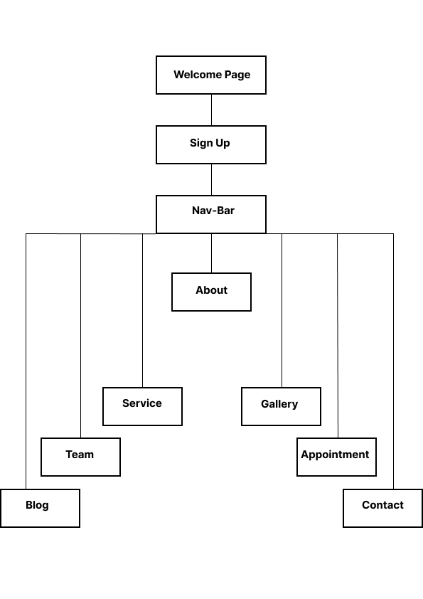

**THANK YOU FOR**

**READING THE**

**DOCUMENTATION.**